**Ideation Phase**

**Brainstorm & Idea Prioritization Template**

|  |  |
| --- | --- |
| Date | 19 November 2023 |
| Team ID | Team-591756 |
| Project Name | E-Commerce Shipping Prediction Using Machine Learning |
| Maximum Marks | 4 Marks |

**Brainstorm & Idea Prioritization Template:**

Brainstorming provides a free and open environment that encourages everyone within a team to participate in the creative thinking process that leads to problem solving. Prioritizing volume over value, out-of-the-box ideas are welcome and built upon, and all participants are encouraged to collaborate, helping each other develop a rich amount of creative solutions.

**Step-1: Team Gathering, Collaboration and Select the Problem Statement**

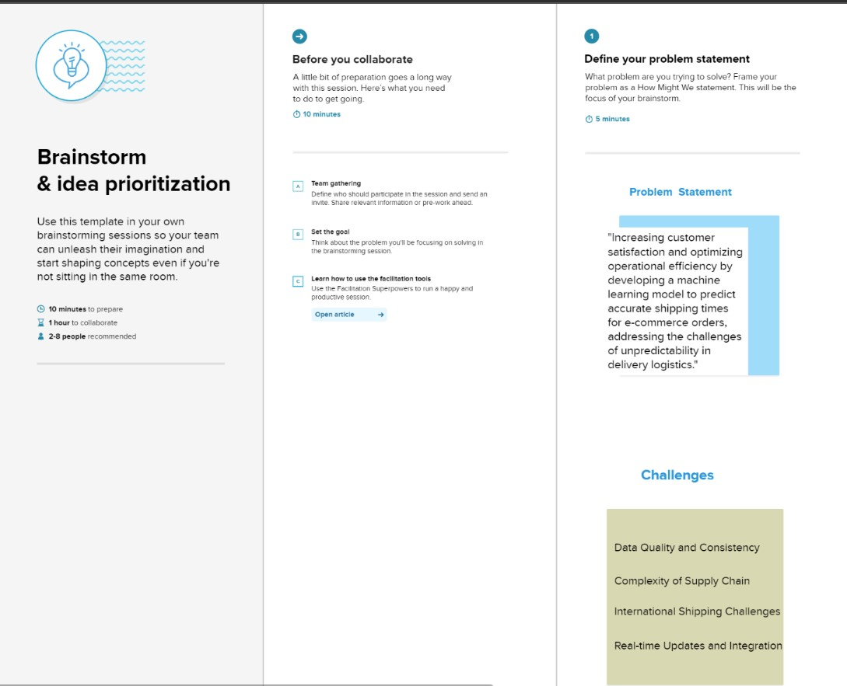

**Step-2: Brainstorm, Idea Listing and Grouping**

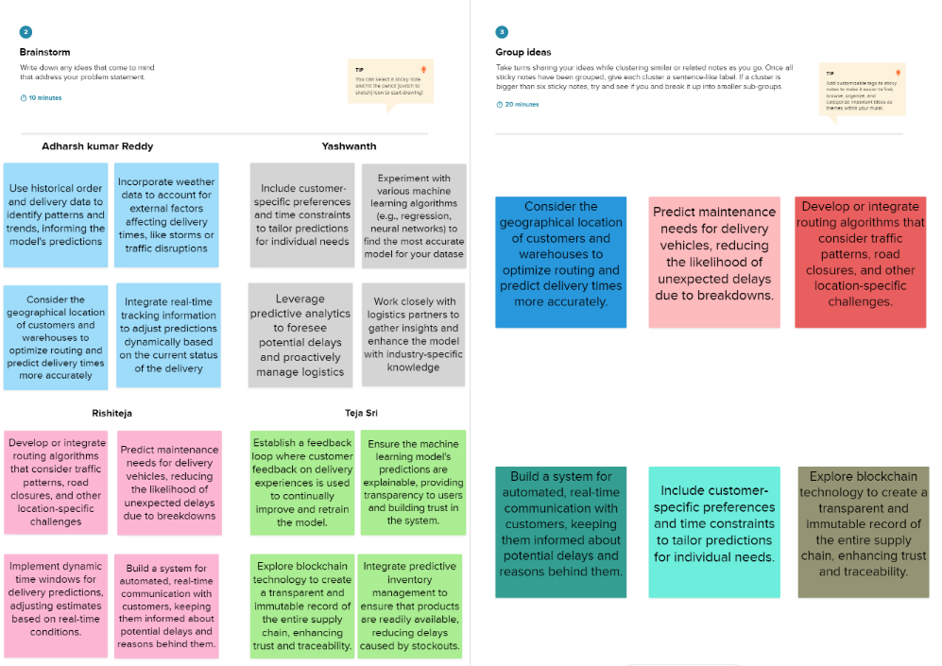

**Step-3: Idea Prioritization**

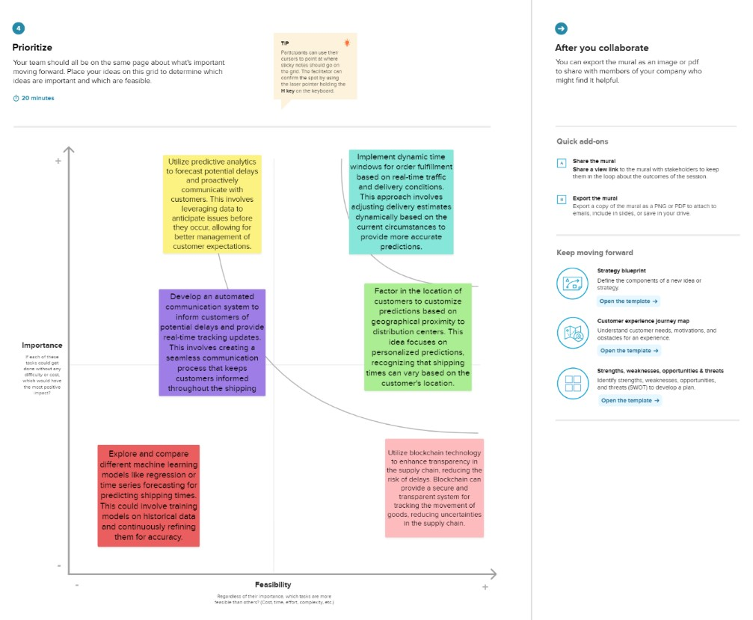

**Reference link(Our mural)-**

https://app.mural.co/t/teamsmartbridge2456/m/teamsmartbridge2456/1699538122256/cc22c8789ed10d078a7ebc71d85ab12922059120?sender=u47eafe4f89c35a704af04977